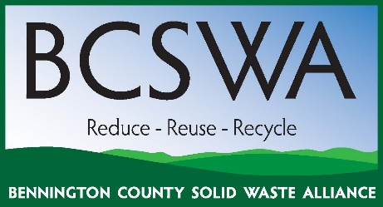 |  | Bennington County Solid Waste Alliance  210 South Street, Suite 6  Bennington, VT 05201  (802) 442-0713 x302

Meeting Agenda
Wednesday Oct. 1, 2025; 4:00 to 5:00 PM
BCRC Office, 210 South St. #6 Bennington, VT 05201 with Remote Option

- Introductions and Remembrance of Stu Hurd 4:00 pm (BCRC Staff) p. 2-3

- Review of Meeting Minutes- 4:03 pm (BCRC Staff) p. 2-3
- BCSWA Officer Elections - 4:05 pm (BCRC Staff)
- FY25 Budget -4:10 (BCRC Staff)
- HHW Facility Operations Update - 4:25 (BCRC Staff)
- Outreach & Events Update - 4:30 pm (BCRC Staff)
- Public Comments 4:40 (Exec. Board)
- Upcoming Meetings and Events - 4: 45 pm (Exec. Board)
  - ISWAP Meeting Casella Contract
  - Dec 2025 Board Meeting

Program Manager Meeting Notes:

